Assignment #3/ due 12/4
Exercise 1: SNR
For this exercise use the following signal: y=randn(1,400)/10+ [zeros(1,100) ones(1,200) zeros(1,100)]+5;
The signal starts at point 101 and ends at 200
- We want the noise to be zero-mean. That is, it will have a mean of zero. Find the value needed to be subtracted from y so that the noise will have zero mean.
In order to achieve mean of zero we need to we need to subtrace the mean (M= 5.4969);
- Compute the noise and signal power.
The noise: 0.1006
The signal power: 6.0034
- Compute the SNRpower , SNRrms and db values.
SNR_{power} | 3561.583041
SNR_{rms} | 59.6790
db values | 35.5164
- In the above we used a normal noise randn(1,400)/10. Change it to randn(1,400)/2, plot the signal you got and calculate the SNR value.
SNR_{power} | 12.0737
SNR_{rms} | 3.4747

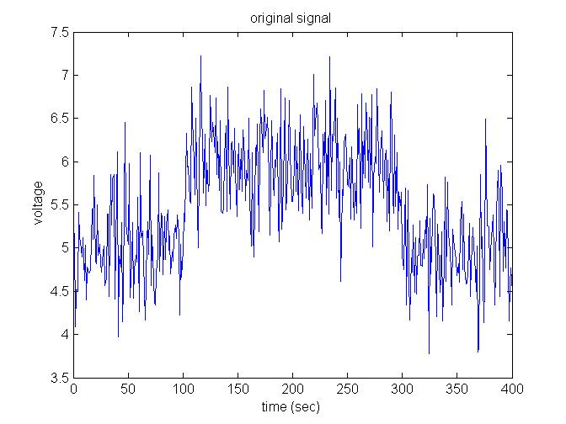
fig1-original signal
Exercise 2: smoothing and averaging
- Use the same signal : y=randn(1,400)/5+ [zeros(1,100) ones(1,200) zeros(1,100)]
- Compute the SNR
SNR_{power} | 12.0737
SNR_{rms} | 3.4747

- Generate n=10 signals like this, average them together and compute the SNR of the averaged signal.
SNR_{power} | 12.0737
SNR_{rms} | 3.4747
- Plot the old and new signal and verify that the new SNR is 10 times the old one.

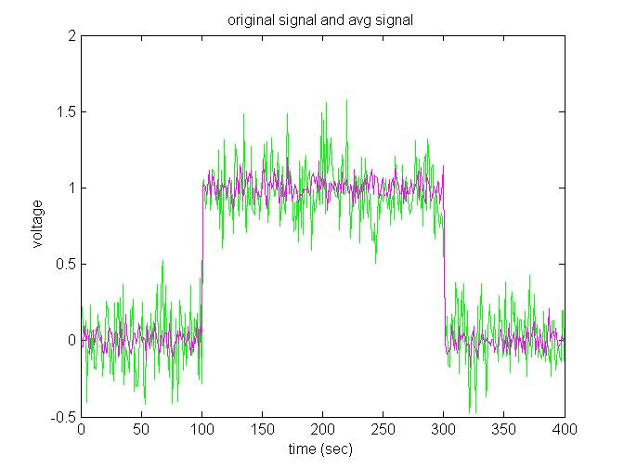
fig2- original signal in green and avraged signal in magenda
- Use the original y signal but now smooth it with a simple 5 points rectangle window (e.g. xi = xi-2+xi-1+xi+xi+1+xi+2)/5. (Do not use the matlab smooth function).
- Plot the smoothed signal and compute its SNR

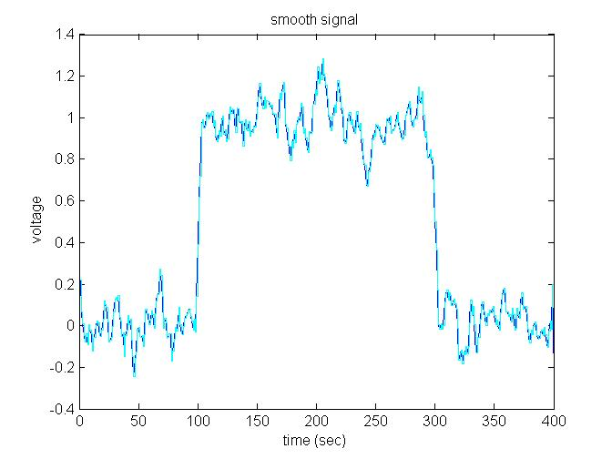
איור 3- smooth signal (cain), and as sqr wave (blue)

Exercise 3: sampling with noise and stochastic resonance
- Assume you have a signal: t=0:0.01:2; y = 10*sin(2*pi*3*t) + 20*sin(2*pi*t*5)
- The signal measures the potential in µV (i.e. 10-6 of a volt)
- The amplifier amplifies the signal by 1000 times. The range of the recording system is 5 Volts and the bit resolution is 8 bits.
- What is the lowest signal this system can measure in µV? Can we capture this signal with this system?
- $Q=\frac{R}{2^{n}}=\frac{5}{2^{8}*1000}=0.00001953125\left[V\right]=19.5313\left[µV\right]$
Wish is higher than the range of the signal, part of the signal will be sampled, but most information about it will be lost.
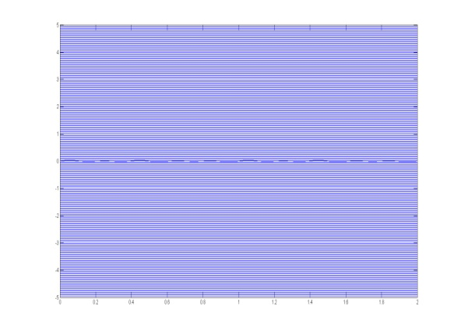
fig4-signal and bit resulotion full view
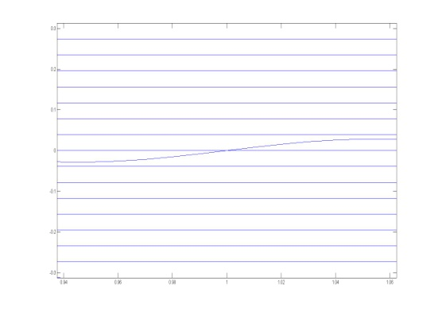
fig 5-signal and bit resulotion closer look

- Sample the signal with a sampling rate of 50 Hz (i.e 50 points/second and you have a signal of 2 seconds).
- Plot the original signal and the sampled signal. The sampled signal should look like square wave signal.
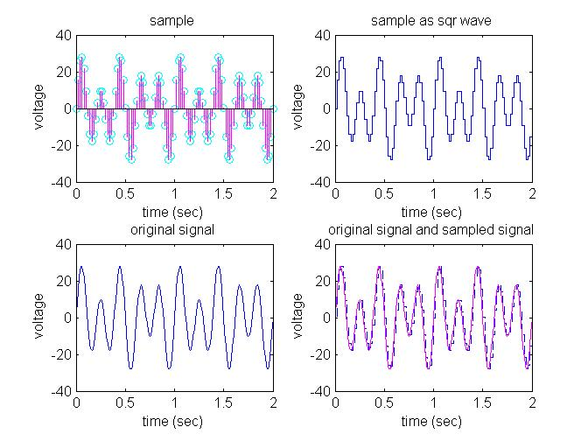
fig6-the signal and its sampling
- Now, add noise to the original signal y by using y=y+20*randn(1,length(t)) ;
- Sample the signal again 100 times and plot the average sampled signal.
